PORTABLE PROGRAMMABLE MEDICATION REMINDER USING PIC MICROCONTROLLER

ABSTRACT

The aim of this project is to remind people who forget to take their medicines on time. Elderly people because of their age usually forget to take their medicines. This project will help to remind the patient to take his/her medicine at prescribed time. The proposed system is best suited for elderly people and people who are very busy, as this device will not only remind them of their medicines with a buzzer sound but also displays the name of the medicine to be taken at that time.
The patient can store the respective time of the particular medicine through a matrix keypad. Based on an RTC (Real Time Clock) interfaced to the microcontroller, the programmed time for the medicine is displayed on the LCD along with a buzzer sound to alert the patient about taking the appropriate medicine. The microcontroller used in this project is of PIC16F8 family. RTC used maintains an accurate time as it is supported by a crystal.
This project in future can be enhanced by integrating it with GSM technology, so that the patient receives a reminder about the medicine he has to take via SMS on his/her cell phone. Also a provision to change the name of the medicine can be incorporated by interfacing the device with a PC or EEPROM (non-volatile memory).

BLOCK DIAGRAM

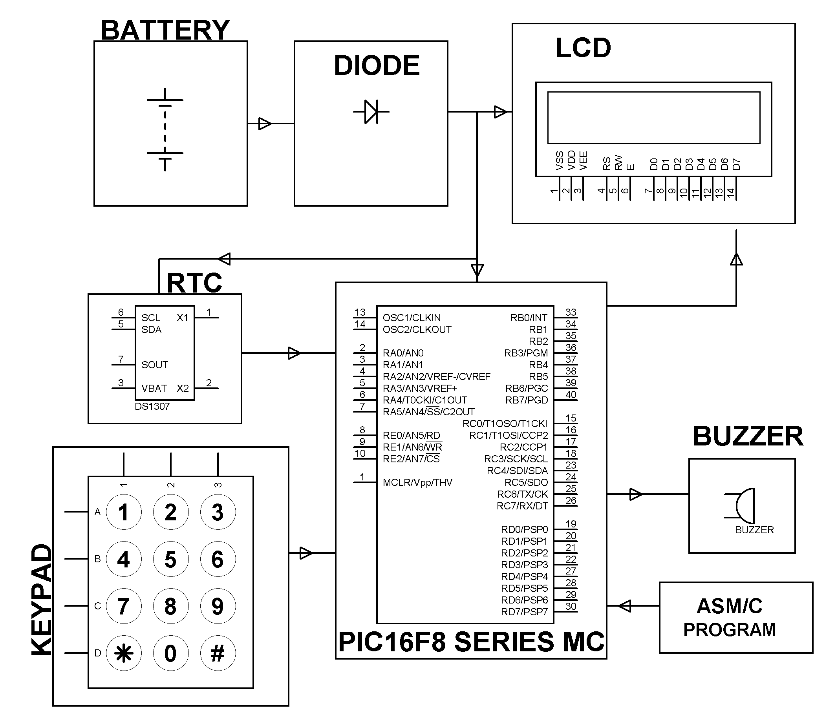

HARDWARE REQUIREMENTS:
PIC16F8 series microcontroller, Keypad, RTC, Battery, Buzzer, LCD, Diode, Resistors, capacitors.

SOFTWARE REQUIREMENTS:
MPLAB & CCS C compiler

Language: Embedded C or Assembly.

